Foundation for Virtual and Augmented Reality Systems
Prof. Samit Bhattacharya
Department of Computer Science and Engineering
Indian Institute of Technology, Guwahati
Week – 05
Lecture – 27
Lec-27: Visual Perception & Displays I
Hello and welcome to the NPTEL MOOC's course on Foundations for Virtual and Augmented Reality Systems. Today we are going to start a new lecture on visual perception and displays. Before we start, as is the practice we are following, let us quickly recap what we have learned in the previous few lectures. So, we talked about the human factors. How they are relevant and why they are relevant?
Because we are dealing with interactive systems. XR systems are essentially interactive systems and human factors play an important role in their design. We have also seen how human physiology dictates how AR/VR systems should be designed, and how they are related. But that discussion was at a very broad level. Now, we are going into a little more detail with respect to each of our senses and how those are useful for the design and implementation of extended reality systems.
So, in this lecture, what we are going to learn about is how our visual senses work and how they determine how to design the visual experience while dealing with extended reality systems. So, essentially we are going to cover the basics of light, lenses and our eyes, and also how these concepts are going to help understand the working of head-mounted displays and other displays that are relevant for immersive experiences. Now, let us quickly have another look at why we should know all these things.
This knowledge is crucial to understand how VR headsets work. Now, of course, it may come to your mind why we are emphasizing VR headsets only when we are dealing with a vast subject covering all extended reality systems and all types of displays. The reason is simple: when we talk of visual displays, visual senses, and we talk of immersive experiences, then the thing that comes to our mind immediately is the headsets, VR headsets. So, essentially, we will be trying to understand in a little more detail how these headsets work.
Earlier, we talked about the hardware, the sensors, and other things. Now, we will try to understand the headsets from the point of view of how they work and why they work. What in our, physiology as well as our behavior makes it work. And we need to know this because we know that light is emitted from the displays and arrives on our retinas, which is part of our eye, and in VR headsets, a system of both engineered and natural lenses guides the light and eventually that leads to visual perception. Now, when I say both engineered and natural, so two types of lenses I mentioned here, engineered lenses and natural lenses. Now, engineered, of course, we understand is the part of the headset; natural means parts of the eyes. So, our eyes also contain lenses, as we all know. When we combine these two lenses, these two types of lenses, the combined system essentially helps us perceive the
immersive visual content. So it is important to know how the light propagates through this combination of lenses and eventually leads us to perceive the scene. There are other reasons also, apart from how perception works. Another reason can be understanding the construction of virtual worlds. So how is that so?
With this knowledge, we can understand the physics of light propagation and accordingly we can model that physics in the virtual worlds that we are using, we are experiencing. Also, we can determine what should be rendered on the visual display depending on this knowledge. Such knowledge is also helpful to understand camera working, how the camera works. Once we know how the light propagates, how our lenses work, then we will also be able to understand how the camera setup works and accordingly in a virtual world we can decide the camera position for the best experience.
So, it provides this knowledge, provides another way to present a virtual world through panoramic videos based on our idea of how camera works, how our eyes work and accordingly how we will be able to receive the videos. Cameras are also important for tracking. So, once we know the working of a camera, it will help us build tracking hardware and software in a better way rather than trying to build it without knowing anything about the vision, about the working of our visual sense.
So those are the reasons, multiple reasons for acquiring the knowledge of how our visual system, visual sense works, how the light propagates, how it propagates through the lenses, through our eyes, how it gets interpreted to let us perceive the scene and so on. That is the knowledge we are looking forward to. Now let us start our discussion on on basic light behavior.
So, unless we know this, we will not be able to understand how perception works, how visual perception works. Now, when we talk of light, we can have three different descriptions of what light is, how to define light. First is in terms of photons, which are tiny particles of energy. moving through space at high speeds. So, when you talk of light, we can think of it as consisting of a large number of photons or particles, energy particles moving through space at a very high speed often called the speed of light. So, if we look at light from this point of view, then that idea will be helpful in understanding the amount of light received by a sensor or receptor. So, if we want to calculate the amount of light that is received at any receptor or sensor, then this idea of photons would be helpful. Another way of describing light is in the form of waves, which are ripples through space.
Now, this description is helpful in understanding the spectrum of color. So, what we generally call color to explain the idea of that color we can explain that in terms of light as wave rather than light as particle. And there can be a third way of describing light also that is in terms of rays. So, these are traces of motion of a single hypothetical photon.
So, when we talk of light we can think of it as a trajectory. A path which is a ray which we assume to be created by a single hypothetical photon. Now, this idea of a ray, this idea of light as a ray is helpful in explaining how lenses work and the concept of visibility. Now that is about three different ways of looking at what light is. One is the particle view that is photons, one is the wave view, and the third one is something derived from the photon but in a different way that is the ray view.
We can use either of these to explain different phenomena related to light. So, one such phenomenon that is of relevance to us is interaction with material. So, when light falls on a material, there is some interaction that happens between the light and the material. Now, there we can try to understand this in terms of light as a ray. As light strikes a material surface, either of three things can occur.
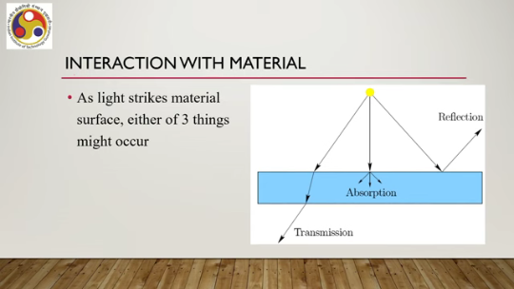
Now, these three things we can visualize in terms of light as a ray as shown in this figure. So, this is the source of light and we have shown the light rays using arrows in this figure. So, this is the material surface. So, once the light falls on the surface, so multiple rays are falling on the surface, some part of the light rays passes through the material as shown in this ray.
So, as you can see, it passes through the material and goes out of the material. So, this is called transmission light transmission. In this case, some part of the ray can get absorbed. So, there is no further propagation of the ray outside the material, unlike transmission. So, as you can see, these three rays terminate within the material, within the object.
So, this is called absorption. So, the object can also absorb the light. The object can allow the light to pass through it. That is transmission. Then we have absorption.
There can be a third thing, that is reflection. So, the ray falls on the surface and then gets reflected from the surface without entering the object, without penetrating the surface. So, these three things can happen. Either of these three things can happen with the light rays. All three together can also happen.
It is not only either. So, the rays can be reflected, absorbed, or transmitted through the surface. Now, when we say that we are seeing a color, that is, when we talk of color perception, what happens? Let us try to understand that in terms of rays and the interaction of light rays with the surface.
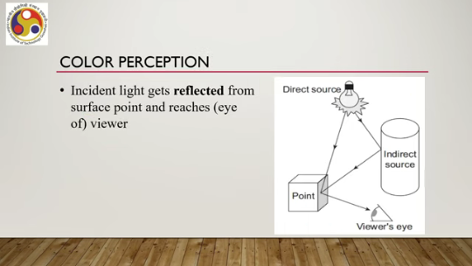
So, there is some incident light. The light, when you say that we are seeing a color, in that case what happens is that the light gets reflected from the surface point and reaches the eye of the viewer. So, as you can see, this is the source of light. The light falls on the surface, then gets reflected, and reaches our eye.
The intensity of the ray that reaches the eye, or the light that reaches the eye, determines what color we are going to perceive. So, intensity of light that reaches the viewer's eye is perceived color, or simply color of the point. So, we have light; light gets reflected from the surface and comes to our eyes. The intensity of that reflected light determines what color we are going to perceive. It may be noted, one more thing may be noted here, is that when I say that the light rays after getting reflected come to our eyes, that is not only the light rays due to direct source, as you can get the idea from this figure, there can be indirect sources, that is, objects surrounding the particular object we are talking about, this one. So, there can be surrounding objects. Light can fall on the surface of the surrounding object as shown in this path, can get reflected, and can get reflected again to mix with the earlier reflected light that is coming from the direct source, and then eventually they together reach our eyes. So, this other one is ambient light. Ambient light is the light in the environment which gets reflected from the object surface along with light coming from the direct source; this light together comes to our eye.
So, the intensity of that combined light light that falls on our eye determines the color. So, that is how we can broadly understand what happens when we perceive color, what happens when we try to perceive a scene. Now, let us shift our attention to the role of visual perception. Now, to design a good system or to understand flaws of a system, we should have some understanding of how our visual perceptual system works.
So far, we have only talked in a very broad sense about how it works, but we should have a better understanding of how the system works. So, in order to get that understanding, let us delve a little deeper into how the human vision system works. In other words, we need to understand how our physiology of vision, vision physiology works. Of course, some of these we have already studied in our high schools, but there is no harm in recapping the concept. As we have already said, light rays come to our eye after getting reflected from surfaces.
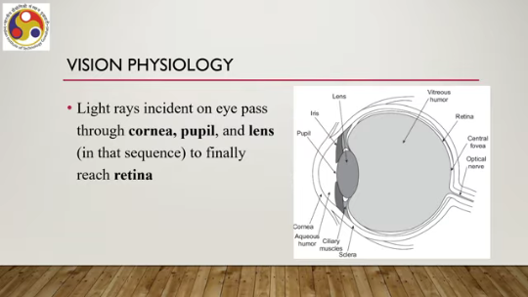
Now, the light rays that are incident on the eye pass through several components of the eye. One is cornea, then we have pupil and lens. In that sequence, first cornea, then pupil, then lens, to finally reach another component that is called retina. So, we have pupil here. Cornea here, this outer surface, and this is the lens as marked here in this figure, then it passes through this medium and finally reaches retina which is at the back side of our eye.
Now, when the light rays are travelling through the eye, the rays get refracted by the cornea and lens to focus images on the retina. So, the material that makes up the cornea and the lens refracts the light. That means light falls here, passes through the surface, emerges from the surface, again falls here, passes through the surface, emerges from the surface, that is transmission. which we have already talked about.
So, we can understand light propagation through the eyes in terms of light as ray and transmission of light rays. The amount of light that is entering the eye is controlled by the iris, that is by dilating or constricting the pupil size. So, pupil size can be changed. Now, iris determines the change.
So, if it wants to let in more, if it is required to let in more light, typically when the surrounding is dark, then the pupil can be dilated to let in more light, or it can be constricted to let in less light. So, when we are in a very bright light situation. Now, the light passes through the cornea, passes through the cornea then the lens and goes to the retina. The retina is composed of optic nerve fibers and photoreceptors. So, if you recall our earlier discussion, we said that visual perception requires the bodily sensors that are called photoreceptors. So, those photoreceptors are part of the retina, which is on the back side of the eye. And the retina also contains optic nerve fibers, that is the neurons that take it to the brain, take the signal to the brain.
Now, there are two types of photoreceptors: rods and cones. So, the human eye contains two types of photoreceptors: rods and cones. Rods are more numerous in the peripheral region of the retina, and cones are mainly in a small central region of the retina, which is called the fovea. So, we have optic nerves shown here, which take the signal to the brain.
We have the central fovea, so this region contains more cones, then these peripheral regions contain more rods; rods are a type of photoreceptor. The whole thing is the retinal part. And you can also see that when light propagates, it goes through several semi-liquid materials such as aqueous humor here, this part between cornea and pupil. Then vitreous humor, this part between lens and retina. So, light passes through several media.
More than one rod. can share an optic nerve which aids in sensitivity to lower levels of light. On the other hand, more or less one optic nerve fiber is there for each cone. So, there can be multiple rods sharing one optic nerve whereas there can be one optic nerve for each cone which aids in image resolution and or In other words, which aids in acuity, image acuity.
So, when we perceive something only with cones, vision accomplished only with cones, that is photopic vision. And when we perceive something with rods only, that is scotopic. So, scotopic is more related to the peripheral vision, photopic is more related to the direct vision or central vision. We perceive colors only in the photopic vision. So, when we say that we are perceiving color, we have to keep in mind that that is due to the photopic vision accomplished with cones.
In scotopic vision, weak lights are visible as a series of grays. So, color perception is not that good. So, photopic vision gives us a sense of color. So, how is color perception related to the light which we have discussed so far? Now, there is something called visible light.
So, we can understand the concept in terms of light as a wave. So, what we call visible light refers to a spectrum of frequencies of electromagnetic light waves. So, when we see light as a wave, we can estimate its frequency, and visible light is nothing but a range of frequencies of the light waves. At one end of the spectrum is the red color. with a frequency of 4.3 into 10 to the power 14 hertz and wavelength 700 nanometer.
At the other end is the violet light with a frequency of 7.5 into 10 to the power 14 hertz, wavelength 400 nanometer. So, at one end we have 4.3 into 10 to the power 14 hertz, light frequency that is perceived as red color, at the other end we have violet color 7.5 into 10 to the power 14 hertz light frequency. Wavelength-wise, red color has 700 nanometer wavelength more as compared to violet which has less wavelength, that is 400 nanometer. So, this range, whatever light falls in, whichever light comes in between this range.
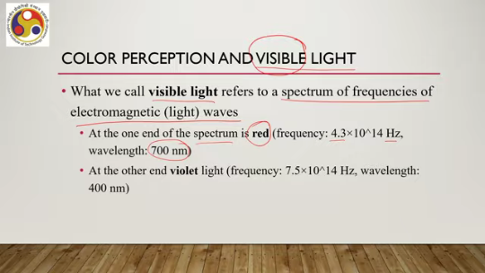
between red and violet, that is called visible light and we are able to perceive visible light using our photopic vision. Now, light waves within this range are able to excite cones in our eye, giving us photopic vision as we have already talked about, which is the perception of color. Light range outside light outside this range cannot excite the photoreceptors that are the cones. So, we do not get any color perception.
So, that is the basic idea of how we perceive color. Then let us try to understand the types of vision that our eyes support. The types of vision are dependent on the density of photoreceptors. So, density of photoreceptors across the retina varies greatly, which results in two types of vision. One is central vision, the other one is peripheral vision.
Central and peripheral, these two types of vision are supported by human eyes. Let us talk about central vision. Now we already mentioned there is a component of our eye that is called fovea which has the greatest concentration of photoreceptors particularly cones. Fovea is the central region of the retina having the greatest concentration of cones. So, the innermost part of the fovea has a diameter of only 0.5 millimeters.
or an angular range of 0.85 plus minus 0.85 degrees and contains almost entirely cones that is the innermost part of the fovea. And this part contributes to our idea of central vision. So, this concentration of cones in the innermost part of the fovea implies that eyes must be pointed straight at a target to perceive a sharp color image. So, if we wish to perceive something, then our eyes must be focused and pointed straight at that object to perceive a sharp color image.
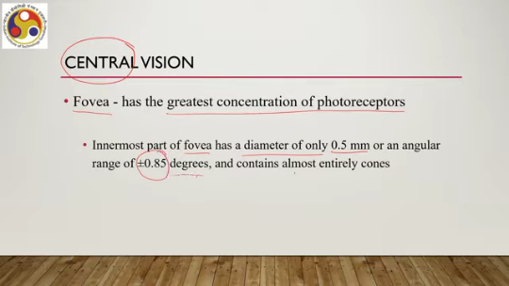
Next, let us try to understand what peripheral vision is. The rays that enter the cornea from the sides land on parts of the retina with lower rod density and very low cone density, that is, towards the peripheral region of the retina. Now, this region where photoreceptor density is less, with a mix of rods and an even lesser amount of cones, is the peripheral region of our eyes, and that leads to peripheral vision.
Now, we are much better at detecting movement in our periphery but cannot distinguish colors effectively. So, that is a very interesting thing. When we try to detect movement, the peripheral region, or peripheral vision, is better than central vision. However, peripheral vision does not tell us about color perception.
Now, this leads to an interesting phenomenon called the blind spot. This is the part of the retina where there are no photoreceptors. So, there is a part where photoreceptors are not there, which is due to the physiology. As our retinas are inside out and have no other way to route neural signals to the brain. So, as you can see here, if we consider this whole part starting from here to here, that is the retina, but,
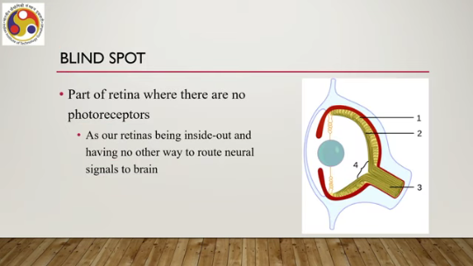
the central part here because these optic nerves need to be placed or attached to the photoreceptors in this manner. 3 indicates the optic nerve component. This region, as you can see labeled as 4, due to the physiology, cannot hold any photoreceptors because light will not come on them because of the density of the optic nerve spreading out around the retina. So, this region
contains no photoreceptors, and accordingly, if light falls in this region, then that will not lead to any perception. So, that part is called the blind spot, a region in the eye where we are blind to the light or to the visual stimuli. So, that is in brief how the physiology of our eye works. So, let us summarize what we have discussed so far. We started our discussion on the importance of visual sense, the importance of knowledge on how the visual sense works, and what are the things that we should need to know.
One part is what is light, the second part is how it propagates, and the third part is how it gets processed in the eye. So, accordingly, we talked about light, we talked about light interaction with materials, we talked about how the eyes receive the light to perceive something, and we also talked about the physiology of human vision. So, in the next part of the lecture, we will talk about how this knowledge can help understand the working of the headsets and displays that we typically associate with immersive experience. So, I hope you have understood the concepts covered in this part. Looking forward to meeting you in the next part of the lecture. Until then, goodbye and happy learning.

